MOON SHADOWS ON RUSH LAKE

ARCHITECTURAL CONTROL
RULES AND REGULATIONS

Date: June 2025

TABLE OF CONTENTS

- Overview
- Architectural Review and Approval Process
- Site Development Standards
- Architectural Standards
- Construction Phase Regulations
- Trash Container Screens
- Solar Energy Systems
Appendix
- Storm Drains
- Planting recommendations
- Trash Screens

- Overview

The intent for Moon Shadows on Rush Lake Condominium Association is the creation of an area that possesses an air of compatibility and consistent high quality design in keeping with and reflecting the unique natural and geological features of the project. It is not the intent of the architectural review process to subdue or restrict the freedom and creativity of the homeowner and his or her architect.

Each site in the project presents a different challenge to relate the improvements to the natural setting. Each presents unique opportunities and unique constraints for sympathetic integration of improvements into the natural environment.

The Association wishes to promote consistent quality in the materials, detailing, architectural proportions, siting, landscaping and overall presence of each residence in the project. That is the underlying basis of the architectural review process.

The Association realizes that opinions vary in such subjective areas as design of a home and personal taste. However, the Association reserves the right to comment and coordinate in as free a manner as possible consistent with the accommodation of individual style and design philosophies.

Compliance with these standards is crucial to the mutual enhancement and protection of the residences in Mon Shadows on Rush Lake, and to the preservation of the uniqueness of this project.

These Rules and Regulations are, of course, subject to the zoning and planning regulations of Livingston County and Hamburg Township, and to other applicable county, state, and federal ordinances, statutes, and regulations, as well as the condominium documents for Moon Shadows on Rush Lake Condominium.

These rules and regulations may be changed anytime by the Board of Directors of the Association, in the interest of quality development of Moon Shadows on Rush Lake Condominium. These rules and regulations are effective December 12th, 2016 and replace all prior inconsistent rules and regulations for this condominium association.

- ARCHITECTURAL REVIEW AND APPROVAL PROCESS

Approval from the Association will be required for any and all improvements constructed on any site within the project, including the initial residence and any additions or changes that occur after construction of the home. The owner or architect must submit the proposed plans to the Board.

A fee may be required for review of architectural plans. This is a one-time fee and will cover all steps of the design review process. The fee may be re-imposed if excessive review is necessary because of extra reviews necessitated by failure to comply with design review guidelines. All drawings must show materials to be used on all projects. Upon approval of the plans, one copy submitted will be signed, dated and returned to the homeowner or architect. If at any point during the process, the homeowner desires to amend or deviate from the previously submitted documents, the matter must be resubmitted indicating specific areas of change. Review of the plans will require no more than thirty (30) days. To expedite your request please submit through email as we do not pick up our mail daily from the P.O. box. All Approvals are good for ninety (90) days. After 90 days the homeowner must resubmit a new Architectural Request.

Design Review
The architect and homeowner will submit three copies of floor plans, site plans, building sections and elevations. The site plan shall include the building site, building footprints, driveway location, any grading or site redefinition, and proposed tree removal. All drawings shall be 1/8” = 1 foot or 1/4” = 1 foot scale.

List contractor(s) name(s) and homeowner who will complete the project. All projects will need final approval. New projects to be completed by the homeowner will only be approved when there are no other uncompleted projects.

All drawings and matters submitted to the Board of Directors must include the owner’s and architect’s name, address and telephone number, and the date and unit number relative to the particular matter submitted. Proposed materials shall be accurately and completely noted on all architectural and/or landscape drawings. Material samples indicating all exterior materials to be utilized for the development of the site will be required. Those samples shall be of accurate color and texture for each material presented. Along with a physical sample, any non-natural or non-wood materials shall have a Product Data Sheet submitted for review by the Board of Directors. Any change in material or construction methods, including landscaping, to an original submitted request, must be resubmitted thru the Design Review process.

Painting. When repainting a home, whether or not a color is changed, please include color samples with your Request Form. The Board may ask that you paint a 3 x 3 foot sample on your house prior to approval.

All trees that the proposal requires to be removed shall be appropriately flagged. No trees, shrubs, or ground cover shall be removed before review and written approval.

Landscaping. Tree replacement of new shrubbery, please indicate the type and size of item being planted.

Proof of insurance that must be carried by the general contractor and/or the owner must be presented to the Association. Such insurance shall include, but not be limited to worker’s compensation, including coverage of uninsured subcontractors, comprehensive general liability (including premises, operations, independent contractor’s protective insurance, product and completed operations coverage, and broad form property damage coverage), contractual liability, personal injury and comprehensive automobile liability insurance.

After submission of all the above documents and proofs, the Board of Directors of the Association will commence their review of these items. The approval or disapproval with comments of the Board of Directors should be delivered to the architect or owner within thirty (30) days of submission of all the above items in the form required; however, more elaborate projects may require forty-five (45) days.

- SITE DEVELOPMENT STANDARDS

General. The preservation of open space, natural features and indigenous vegetation, and the integration of residential design into the site are the principle goals of the site development standards for Moon Shadows on Rush Lake. All structures must be built entirely within the boundaries of the site/unit. Building siting shall be responsive to existing features of terrain, drainage patterns, natural geological features, vegetation, views and sun exposure. Landscaping and grading for any site shall blend with all adjacent properties.

Grading. Grading requirements resulting from development shall be designed to blend into the natural landscape. Ideally, grading shall be kept to a minimum. Cuts and fills should be feathered into existing terrain within the site boundary. Slope of cut and tilt should be determined by soil characteristics, but in any event, should be limited to a minimum of 2:1 slope. During construction of a home on the site, any areas of the site that have been graded should be planted or otherwise naturally treated to minimize erosion.

Natural Drainage. No drainage improvements shall interfere with or redirect the natural flow or course of any drainage runoff from a site. Neither volume nor velocity of runoff may be increased from a site. Surface drainage improvement shall be constructed of natural materials; please provide examples (i.e. sand, gravel, rip rap, etc.). The use of exposed drain pipe or impervious man-made swale lining materials is forbidden. Naturally appearing drainage areas shall be constructed using native or natural materials, rock lined and following natural lines of flow. Drainage shall not infringe on neighboring sites.

Foundation Excavation. Foundation and basement excavation, and foundation trenches shall be located so as to prevent damage to tree roots. In situations where this is not possible, contractors shall exercise great care to minimize damage to the root. Where roots have been damaged or exposed, trenches shall be backfilled with loose soil. All backfill shall be kept moist until being replaced.

Retaining Walls. If retaining walls are required by any approved improvements to the site, they shall be made of native stone, colored sandblasted concrete, wood timbers, or other materials that are complementary to the natural surroundings.

Fences, Walls and Barrier Devices. The greatest preservation of natural landscape would be realized if no fences were built. However, there are acceptable functional reasons for fences (i.e. pool perimeters). Where a fence is necessary, a wrought iron type, similar to the fence used on the M-36 border of Moon Shadows on Rush Lake, should be used. The Board of Directors of the Association will review the design of any and all proposed fences, walls, and barriers and their appropriateness, size and appearance in relation to the proposed residence and adjacent sites. Barriers used solely as property line delineation will not be approved under any conditions.

Garages, Car Ports, and Parking Spaces. Garages will be integrated with the design of the house. Car ports are forbidden. Garages should be oriented so as to not open onto public roads or have expanses of garage doors visible from the road. Trailers, mobile homes, trucks, pickups, boats, boat trailers, tractors, vehicles other than automobiles of co-owners, snow removal equipment and garden or maintenance equipment shall be kept inside the garage at all times except when in actual use. Exception: Following exhaustion of all other options, snow removal equipment and garden or maintenance equipment which cannot be stored within the garage may also be kept in an unsightly area of attachment to home but only if screened in and/or unsightly from street or neighbors. All such storage areas shall be subject to review by the Board of Directors. No automobile repair work shall be performed anywhere within the site except in enclosed areas or in cases of emergency. Each home constructed on a site shall provide for a garage large enough to accommodate at least two cars; all garages shall be attached to the house constructed on a site.

Driveways. The width of driveways shall be, at a maximum, the width of the garage opening. In all cases, access drives shall be paved and should generally follow the natural contours of the site, meandering around and between existing trees and geological features. Long straight runs, even if possible, should be avoided in order to maintain a natural appearance. Generally, road beds cut into slopes are preferable to fill areas. Driveway plans will be submitted for approval at the design review stage, as set forth above. The only approved access during the construction period will be over the approved driveway. Driveways represent a great potential for negative impact on a site; accordingly, care should be taken in planning and design to reduce their dominance.

Decks, Greenhouses, Terraces, Etc. Decks should be designed to minimize unsightly supporting structures, especially when viewed from below, and to compliment the total design. Greenhouses and recognized appurtenant amenities are acceptable, but must meet all the zoning and planning regulations of Livingston County and Hamburg Township, and all other applicable county, state, and federal ordinances, statutes, and regulations, as well as the condominium documents for Moon Shadows on Rush Lake Condominium, as do other architectural features. They should, like all other features, demonstrate an integration with the design of the residence and the site planning characteristics. Terraces and porches should be designed so as to be an extension of the architecture of the home and to be integrated into the natural form of the land.

Utility Meters, Air Conditioners, Garbage Areas and Satellite Receiving Equipment. Utility meters and air conditioner units are to be hidden by landscaping. These and other related utilitarian features shall be screened, buried or enclosed from view and planned as a part of the total design. Any additions to any residence after the owner has occupied the home will require an additional approval process and resubmittal of plans and designs similar to that required for construction of the home. Trash containers and garbage shall be inaccessible to wildlife and are to be enclosed with the structure (presumably the garage) except during garbage collection periods. Satellite receiving equipment is prohibited unless enclosed in the attic area of the home or unless the dish is no larger than 24 inches in diameter, and is limited to one appurtenance; any additional structures to roofs must be approved by the Board of Directors.

Revegetation and Landscaping. The general philosophy of Moon Shadows on Rush Lake Condominium is the encouragement of the existing state of nature and the design of the living area to be an extension of the natural surroundings. The existing state of nature is defined, for purposes of these architectural restrictions, as a combination of indigenous plant material, trees, top soils, rock formations, natural terrain and other geological features that exist before construction on and around the site. Installation and maintenance of plant materials and other landscape related improvements on the site are the responsibility of the owner.

Signs. House address numbers shall not exceed 5” in height. One construction sign during the period of construction of the house is allowed; such construction signs shall not exceed nine square feet in total face area. Real estate signs, if allowed by special approval of the Association, shall not exceed six square feet in total face area.

Outdoor Lighting. All outdoor lighting must be specified during the design review process. Lighting of parking areas, driveways or walkways to houses should be considered. Indirect lighting is preferred. If driveway lighting is necessary, its design shall be such that no glare shall be visible to persons using the roadways or to neighboring properties. Driving lighting design shall not emphasize the driveway as a major site feature, but shall be for visibility purposes only. The general intent regarding outdoor lighting at the project is to provide functional lighting that enhances an overall appearance, but is not disturbing to neighbors or motorists, and is not intended for general area lighting, especially if light encroaches on neighbor’s property. Any lighting for a purpose outside of this intention is subject to review by the board of Directors.

Trees. Building and other improvements shall be located on the site where they have the least effect upon the naturally occurring flora. Trees shall not be cut and tree roots shall not be disturbed for trenching or construction without specific approval of the Board of Directors of the Association. All trees will be flagged for removal as part of the design review submission. Trees or groups of trees adjacent to the construction area shall be protected during the construction period. Trees and other existing vegetation are valued by the Association. It is mandatory that the specifications and the building contract between the owner and contractor clearly define the intent to preserve existing plant life. The owner or contractor who damages trees, shrubs or ground cover shall be required to replace such plants or trees by appropriate replanting. All trees removed for construction shall be promptly removed from the site or treated to prevent infestation. Any fallen, dead or infected trees shall be removed from site immediately. If the removed tree is part of the general landscaping the homeowner may be required to replace the tree. The nailing of signs, permits or other items to trees is not allowed.

Landscape and Planting Materials. The scale of landscape and overall landscape design shall be planned so that new vegetation is integrated with the natural landscape and the form, colors and texture of indigenous flora. New planting should utilize plants that are indigenous to the State of Michigan and should be located so as to extend existing hedges, patterns or naturally occurring formations. Tall grasses and underbrush around larger trees should be removed so as to not provide combustible fuel for wildfires. The lower deadwood on tree trunks, especially common on conifers, should be removed for the same reason. Plant materials used for erosion control shall establish immediate surface stabilization to prevent soil erosion. Diverse, self-sustaining plant species shall be used to provide surface cover within one growing season.

Wells and Sewage Disposal. Each individual residence constructed upon a site shall be serviced by its own water well and septic system. The owner of each condominium is responsible for the maintenance, repair and replacement of all water supply and sewage disposal facilities on his or her unit. All wells shall be drilled by a licensed Michigan well driller and shall penetrate a protective clay layer sufficient to protect the aquifer. If a protective clay layer is not encountered in drilling, the well shall be drilled to and terminate in the bedrock formation beneath the unit. If test wells are drilled and are not to be used as service wells, then they shall be properly abandoned by a licensed Michigan well driller, who shall provide written certification as to abandonment to the Livingston County Health Department. Isolation and construction requirements for private well construction shall meet the minimum requirements set forth by the Livingston County Health Department and Section 127 of 1978 PA 368. Unless otherwise approved, all wells and septic systems shall be located within the approved areas as shown on the final site plan on file with the Livingston County Health Department. All restrictions placed on the condominium project by the Livingston County Health Department are not severable and shall not expire or become ineffective unless amended or changed under approval of the Livingston County Health Department.

Storm Drain Discharges. The owner of each condominium which houses a storm sewer discharge pipe is responsible for the maintenance of all grounds adjacent to said discharge. This maintenance shall maintain natural flow out of the discharge pipe, and shall avoid any restrictions. The discharge water is intended to flow along open ground, to allow infiltration prior to entering the Association water retention ponds. It is required that this maintenance, and associated materials used, are in alignment with the Moon Shadows on Rush Lake Condominium Association StormWater Management Master Plan included in Appendix A; and the maintenance must also comply with the Livingston County Drain Commission regulations.

- ARCHITECTURAL STANDARDS

General. Only site-built homes are allowed. No modular, mobile, manufactured or factory-built homes shall be constructed or placed on any Unit in the Project.

Exterior Walls. Materials allowed for exterior walls are: brick, natural wood siding, cut stone where integrated with the design, exposed architectural concrete (at the sole discretion of the Board of Directors, especially when stained, sandblasted and/or textured), architectural concrete block and stucco. Materials not recommended or acceptable for exterior walls are: metal siding, synthetic siding, standard concrete block, adobe, contrasting light or dark grout colored mortar, wood shakes and unnaturally colored brick masonry. Foundations should be covered with cut stone, brick or stucco as a veneer over concrete walls or blocks or painted to blend in with the house color.

Roofing Materials. Wood shingles, heavy gauge asphalt shingles, wood shakes and skate roofs are allowed. Standing seam metal roofing is not allowed except for bay-bow areas. Flat roofs will be considered on an individual basis, but are not encouraged except as linking devices and as minor architectural elements.

Windows: Insulated glass windows are required. Double or triple dual high-performance glazing is recommended. Windows must have high quality frames that will promote window durability and create an attractive appearance to the home so as to support neighborhood property values. Wood frames are encouraged but not required. Any non-wood frame window request must provide adequate supporting information to enable review/approval to conclude the non-wood frame window is a reasonable substitute for a wood-framed window. Vinyl or Aluminum clad exteriors encouraged but not required. All finishes must be either natural or painted to natural colors. Other materials, such as anodized metal, will be approved at the sole discretion of the Board.

Finishes. Transparent finishes that enhance the natural materials of construction are preferred. Semi-transparent and solid base stains and paints which relate to the surrounding natural coloration are acceptable. All exposed metals, sheet metals or primed woods shall generally be painted to natural muted, non-contrasting colors. TV or radio antennas are not acceptable on the exterior of residences.

Decks. Decks must be of treated material and all material and deck designs must be approved by the Board.

Exterior Doors. Simple designs are preferred. Ornate or gaudily designed doors are not acceptable. Antique doors are acceptable if approved by the Board. Metal security bars on door and window openings are not acceptable.
Exposed Metal, Chimney, Vents. All exposed metal, fascia, flashing, wall vents, roof vents, metal enclosures and chimneys, shall be carefully considered elements in the design composition and shall be colored so as to blend with the natural surrounding where possible. Reflective or contrasting finishes will not be acceptable. Spark screens are mandatory on all chimneys. Care should be given to chimney location and existing trees for fire prevention. Vents shall be located lakeside (non-street side) elevations of all residences.

Skylights. Only flat, glass skylights will be approved on sloped roofs. Bubble or gable skylights will be considered individually for flat roof applications, where allowed.

Docks and Marine Area.

All Condominium owners that own a dock parcel must maintain the dock and surrounding area in good condition and to maintain the parcel in a safe and clean manner. The same care Condominium owners are required to apply to their home lots should be applied to their dock parcel.

Miscellaneous. The following items are not allowed at Moon Shadows on Rush Lake: Flimsy or unsubstantial, visually or structurally, awning and patio covers, etc.; metal storage buildings of any type or size; exposed trash or refuse containers; nonconforming mail boxes; above ground pools; the use of power vehicles of any type on the ponds. If any damage occurs to the common areas and evidence exists showing the damage was caused by a homeowner, then the Board of Directors shall have the right to submit all costs of repair for such damage to the homeowner.

Dimensional Requirements. Any residence constructed on a unit shall contain the following minimum square footage:

- One story dwelling, 2,000 square feet on the ground floor
- One and one-half story dwelling, 1,400 square feet on the ground floor, and a total 2400 square feet of living area
- Two story dwelling, 1,200 square feet on the ground floor, and a total 2400 square feet of living area
- Tri-levels and quad-levels, not less than 800 square feet in each of the top two levels, and a total 2400 square feet of living area

In making computations of square footage, there shall not be included basements (including finished walk-out areas), garages, attics, breezeways, porches and similar areas which are not normally classified as living areas. Building heights shall not exceed 35 feet. Heights will be measured vertically from the finished grade to the highest part of the roof or building element, excluding chimneys.

- CONSTRUCTION PHASE REGULATIONS

Because construction of residences will take place over a substantial period of development, in order to maintain a comfortable, controlled atmosphere for current residents at Moon Shadows on Rush Lake during the construction of other residences, the following regulations shall be observed during the construction period. Each of these regulations shall be incorporated into the construction contract documents for each home site.

Construction Boundaries. The contractor and architect shall establish construction boundaries around the perimeter of the foundation excavation. No vehicles or equipment, chemical toilets, dumpsters, material storage, etc. will be allowed outside of this area.

Construction Trailers, Sheds or Temporary Structures. Use of construction shelters shall be approved in writing by the Board of Directors, prior to installing them on the site. Size, configuration and location restrictions, as approved by the Board shall be observed. All temporary structures shall be removed immediately after issuance of a certificate of occupancy.

Daily Operation. Daily working operation hours for each construction site shall commence no earlier than 7:00 am and end no later than 6:00 pm.

Debris and Trash Removal. Daily cleanup of the construction site is mandatory. Proper disposal of refuse and storage of material is of prime importance and is the contractor’s responsibility. Debris and trash shall be removed on a regular periodic basis by being hauled to a designated and authorized public dump area outside of the project. After the contractor has been requested to remove the construction debris or trash and has not cooperated, the Board of Directors may have it removed, at their option, and charge the contractor and the owner for the costs incurred. Unauthorized burning of trash or construction debris is prohibited within the project.

Storage of Construction Material, Trash and Equipment. Storage areas shall be limited to the approved construction limits areas designated above. The contractor will be responsible for maintaining and storing construction materials, trash and equipment only in these areas.

Chemical Toilets. Chemical toilets shall be provided and properly maintained by the contractor and placed in an approved location.

Vehicles and Parking. All vehicles will be parked only in the designated areas shown on the site plan so as not to inhibit traffic or damage the surrounding natural landscape. Vehicles shall not be left on the roads over-night. Vehicles may not be parked on other lots or on open space lands. The only approved construction access during the time a home is being built will be over the approved driveway area for the site unless otherwise approved by the Board of Directors. Construction machinery may not be kept on a given site for more than seven (7) days without approval of the Board of Directors.

Speed Limit. Vehicle speeds shall not exceed 25 m.p.h. on any roadway unless otherwise posted.

Dust, Noise, and Odor. Every effort shall be made to control dust, noise and odor emitted from a construction area. Radios, tape players or other such devices must be played at low volume.

Fire Extinguishers. A minimum of one serviceable 1016 ABC rated dry chemical fire extinguisher shall be located on each construction site in a conspicuous location.

Construction Activity Restricted to Lot. All construction activity shall be contained on the lot for which building permit has been issued unless specific authorization is received in writing from the Board. All soil, boulders, building materials, etc. shall be maintained inside the lot boundaries and not allowed on any roads. Any common ground, adjacent lots or roads damaged during construction shall be promptly restored to their original condition to the satisfaction of the board of Directors by the owner and his contractor. If restoration is not accomplished by the end of the growing season following completion of construction, then all required repairs may be performed by the Board of Directors and the cost thereof shall be charged to the owner of the property or the person in whose name the building permit is issued, or both.

The Following items are prohibited at the project:

- Changing of oil in vehicles and equipment without proper receptacles and removal procedures;
- Concrete equipment cleaning or concrete dumping without proper cleanup and restoration;
- Careless treatment of trees or preservation areas;
- Removing rocks, trees, plants, top soils, etc. from any portion of the project other than the owner’s property;
- Exceeding the speed limit;
- Careless use of cigarettes o flammable items;
- Burning of trash or construction debris;
- Possession or use of firearms on the project;
- Unapproved construction or real estate signs;
- Disturbance of designated wetlands by contractors, subcontractors or owners;
- The intentional disruption or scarring of wildlife.

- Trash Container Screens

Rationale:
Trash container screens would help maintain aesthetics of our community. We need an option to hide trash containers, especially with the addition of large recycling containers. Examples of trash container screens can be found in Appendix C, however, these are not exhaustive of designs which can be approved.

Garage storage of trash containers is not always possible due to size constraints.

Summer storage of trash containers in garages is not appropriate due to heat and resultant odor.

Requirements:

- Architectural request forms are required before installing a screen. Approval by the architectural committee is required with final inspection after completion.
- Screen must be adjacent to the house. No free-standing screens are allowed.
- Size: Maximum Square Footage: 24 sq. ft.
Maximum Height: 55”
- Screen will be used only for trash and recycling containers.
- Design and material must compliment architecture of existing home and community.
Materials Allowed: Natural Wood, Brick. Wood screens must be finished with a natural wood stain or painted, matching adjacent structure (no contrasting colors). Brick must match brick already on the home. Homeowners may also choose to screen the trash containers with landscaping (bushes).
Materials not allowed: Vinyl, synthetic materials, aluminum siding, standard concrete block, adobe, other metal siding, plastic.
- Screen must be completed within 90 days of project start date.
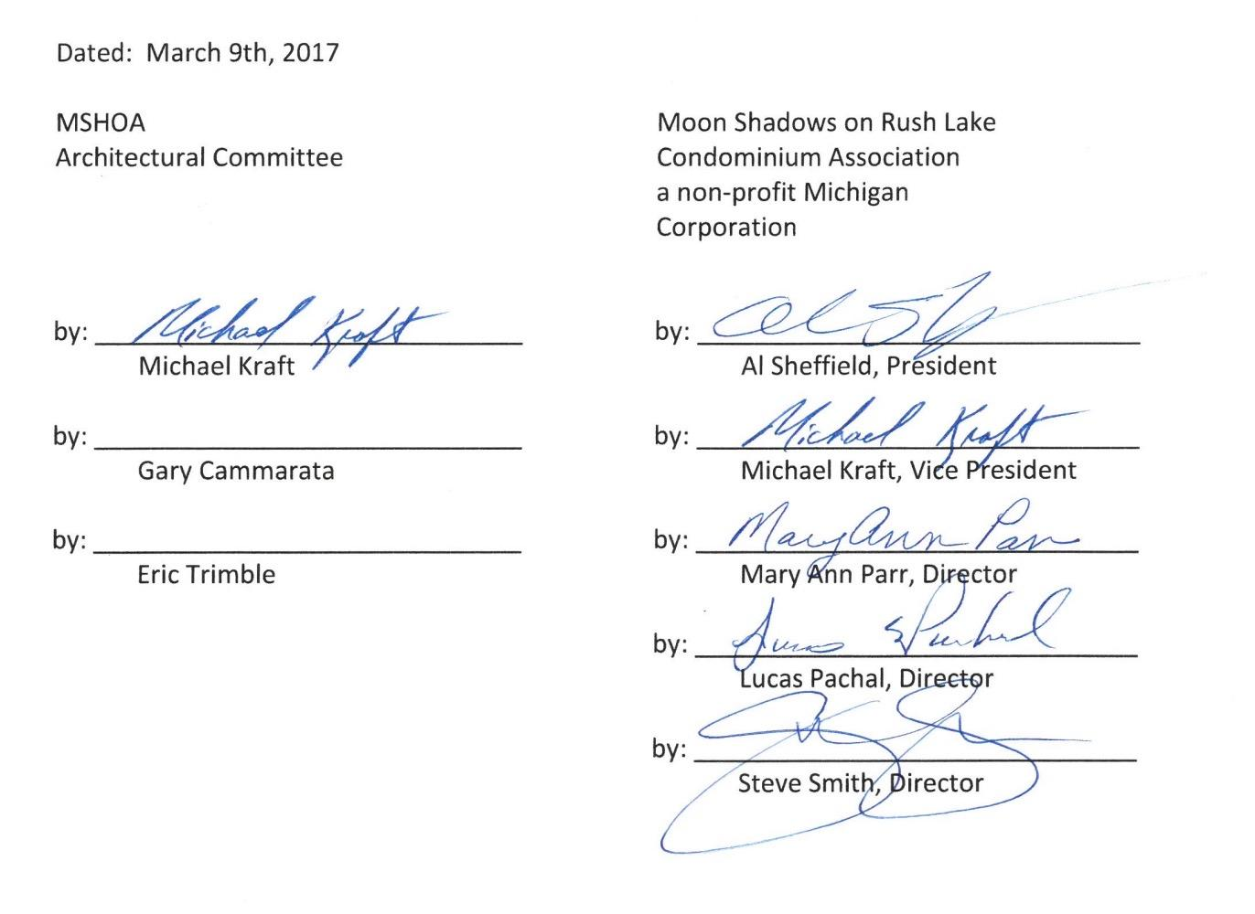

VII: Solar Energy Systems

MOON SHADOWS ON RUSH LAKE HOMEOWNER ASSOCIATION

SOLAR ENERGY POLICY STATEMENT

The Board of Directors of Moon Shadows on Rush Lake Homeowner Association (the “Association”) adopts this Solar Energy Policy Statement (“Policy”) on the 7th day of June, 2025, effective July 1, 2025.

BACKGROUND

- The Association is responsible for the governance, maintenance, and administration of Moon Shadows on Rush Lake (the “Condominium”).
- The Association’s Board of Directors (“Board”) desires to adopt rules governing the installation, maintenance, and use of Solar Energy Systems (defined below) within the Condominium.
- This Policy establishes guidelines for the replacement, maintenance, installation, or operation of Solar Energy Systems by Association Members (defined below), in compliance with the Homeowners’ Energy Policy Act (Public Act 68 of 2024) (the “Act”).

The Association’s Board adopts this Policy, which is binding upon all Co-owners and their tenants, occupants, successors, and assigns, and which supersedes any Governing Document (defined below) provisions and previously adopted rules on the same subject matter:

DEFINITIONS

- “Common Area” means a portion of a building, land, or amenities owned or managed by the Association that is generally accessible to all Members, including, without limitation, roads, sidewalks, wetlands, or open spaces.

- “Energy Saving Improvement or Modification” means and includes, but is not limited to, clotheslines, air source heat pumps, ground source heat pumps, insulation, rain barrels, reflective roofing, energy efficient appliances, solar water heaters, electric vehicle supply equipment, energy-efficient windows, and energy-efficient insulation materials.

- “Governing Documents” means the Association’s Master Deed, Bylaws, and rules and regulations, all as may be amended.

- “Limited Common Element” refers to any area of the Condominium which is defined as a Limited Common Element under the Governing Documents.

- “Member” means a Co-owner of a Unit within the Condominium.

- “Solar Energy System” (SES) means a complete assembly, structure, or design of a solar collector or solar storage mechanism that uses solar energy for generating electricity or heating or cooling materials.

ENERGY SAVING IMPROVEMENTS OR MODIFICATIONS

- Energy Savings Improvements or Modifications within a Unit or a Unit’s Limited Common Elements. Any provision in the Association’s Governing Documents that prohibits or requires approval for the replacement, maintenance, installation, or operation of Energy Saving Improvements or Modifications within their Unit or the Unit’s Limited Common Elements is invalid and unenforceable. Members are not required to request or obtain approval from the Association to install an Energy Saving Improvement or Modification within their Unit or Limited Common Element areas.

- Auxiliary Changes. Members are not required to obtain Association approval for auxiliary changes necessary for the installation of Energy-Saving Improvements or Modifications located within their Unit or Limited Common Element areas.

- Prohibition of Modification or Alteration within Common Areas. Members are prohibited from installing Energy Saving Improvements or Modifications within any Common Area without first obtaining the Board’s prior written approval. The Board has the right to refuse to approve any proposed Energy Savings Improvement or Modification installed in any of these areas that is not suitable or desirable in its opinion for aesthetic or any other reason.

SOLAR ENERGY SYSTEMS

- Application Process for Solar Energy Systems.
- Application Required. A Member desiring to install a Solar Energy System in the Member’s residence or on their Unit, or which requires modification of a Limited Common Element or Common Area, shall submit a written application to the Association prior to installation. The written application must include all of the following information:

- The Member’s name. [Must have legal title or exclusive control over property]
- The street address of the location where the Solar Energy System will be installed.
- The name and contact information of the licensed and insured person who will install the Solar Energy System.
- An image showing the detailed layout of the Solar Energy System on the member’s residence or Unit. Provide roof photos and/or elevations
- A description of and specifications of the proposed Solar Energy System to be installed.
- The SES complies with all applicable federal, state, and local building codes, safety standards, and permit requirements.
- The SES system meets industry standards such as UL (Underwriters Laboratories) certification or equivalent.

2. Time Frame for Approval or Denial. The Board must approve or deny the Member’s request to install a Solar Energy System within the Unit’s Limited Common Elements, in the Member’s residence, or on their Unit within 30 days after receipt of the written application. The criteria for denial are described in Section III(B) below. If the Board fails to approve or deny the Member’s application within 30 days of receipt, the Member may proceed with the installation of the Solar Energy System within the Unit’s Limited Common Elements, in the Member’s residence, or on their Unit, as applicable. This provision does not apply to Common Areas.

3. Application Resubmittal. A Member may resubmit a written application to install a Solar Energy System within the Unit’s Limited Common Elements, in the Member’s residence, or on their Unit, which was submitted to and denied by the Board before the effective date of the Act. Upon receipt of the resubmitted written application, the Board shall reevaluate the application in accordance with the Act. This provision does not apply to Common Areas.

4. Approval of Individual Members not Required. The approval of any individual Member, including any Member owning a Unit adjacent to the applying Member, is not required to approve a Member’s application to install a Solar Energy System within the Member’s residence or Unit.

5. Compliance with Policy and Act. The Board will review applications based on compliance with this Policy and the Act.

6. Application Fee. The Association may charge a reasonable fee for reviewing written application requests for the installation of a Solar Energy System, which fee shall not exceed the amount established for reviewing any other request for modification or alteration of the residence or Unit.

7. Prohibitions on Association. In reviewing an application for installation of a Solar Energy System, the Association will not do any of the following:
- Inquire into a Member’s energy usage.
- Impose conditions that impair the operation of a Solar Energy System
- Impose conditions that negatively impact any component industry standard warranty.
- Require post-installation reporting.
- Require a fee for submitting an application to install a Solar Energy System above that which it assesses for other applications related to a change to the property.
- Prohibit a Member from resubmitting a written application to install a Solar Energy System after the Association denied a written application submitted after the effective date of this Act.
- Require approval from adjacent homeowners for SES installation.
- Deny a Member’s application to install a Solar Energy System because of the identity of the entity that owns the Solar Energy System or the financing method chosen by the Member.
- Impose standards that reduce the system’s annual electricity production by more than 10% or increase installation costs by more than $1,000.

B. Installation of Solar Energy Systems in General

- Common Areas. Section B does not apply to Common Areas.

- Criteria for Denial or Removal. The Board may deny an application to install a Solar Energy System or require the removal of a Solar Energy System if one or more of the following apply:

a. A court has found that the installation of the Solar Energy System violates a law.

b. The installed Solar Energy System does not substantially conform to the Member’s application to install the Solar Energy System as approved by the Board.

c. The Board has determined that the Solar Energy System will be installed on the roof of a residence of the Member requesting installation and one or more of the following apply: (i) the Solar Energy System will extend above or beyond the roof of that home by more than six (6) inches; (ii) the Solar Energy System does not conform to the slope of the roof and has a top edge that is not parallel to the roof line; (iii) the Solar Energy System has a frame, support bracket, or visible conduit or wiring that is not silver, bronze, or black tone that are commonly available in the marketplace; (iv) the SES is damaged or inoperable; (v) the SES no longer complies with applicable laws and regulations.

d. The Board has determined that both of the following apply: (i) the Solar Energy System will be installed in a fenced yard or patio rather than on the roof of a home; and (ii) the Solar Energy System will be taller than the fence line.

3. Location Preferences. Although not required, the Board prefers that Members minimize the visibility of Solar Energy Systems from the roadway that fronts the Member’s Unit and from outside the Unit to the extent possible, including the preference that the inverter be located inside the Residence.

4. Color Preferences. Although not required, the Board prefers that the Solar Energy System and mounting system be compatible in color with the established roof materials.

5. Requirements. A Member shall comply with state and local building codes and permit requirements in the replacement, maintenance, installation, or operation of an energy-saving improvement or modification, or the installation of a Solar Energy System.

6. Maintenance, Repair, and Replacement. Members are responsible for maintaining, repairing, and replacing their Solar Energy System. Members shall ensure their Solar Energy System remains in good condition and repair, and in compliance with all applicable State and local building codes and permit requirements. Any replacement Solar Energy Systems or components must comply with this Policy.

7. Conform to Policy Statement. Any proposed Solar Energy System installation must conform to the terms of this Policy Statement.

8. Installation of Solar Energy Systems in Common Areas. Notwithstanding any other provision contained in this Policy, including, without limitation, the provisions contained in Section B above, no Member may install a Solar Energy System in a Common Area without first obtaining the Board’s prior written approval. The Board has the right to refuse to approve any proposed Solar Energy System installed in any of these areas that is not suitable or desirable in its opinion for aesthetic or any other reasons.

* * * * *
Respectfully submitted,
Board of Directors, Moon Shadows on Rush Lake Homeowner Association

MSHOA Homeowner’s Solar Installation Application Checklist
(Please ensure all items are submitted with your Architectural request to the Architectural Committee.)

Homeowner Information
☐ Full name of homeowner(s)
☐ Property address
☐ Contact information (phone &amp; email)

Installer Information
☐ Name of licensed solar contractor
☐ Business license number and expiration
☐ Proof of liability insurance and bonding
☐ Installer contact details (phone, email, business address)
☐ Local building permit approval (if already obtained; if not, indicate pending)

System Specifications &amp; Design
☐ Product specifications (make, model, quantity)
☐ UL certification or equivalent for all major system components
☐ Layout diagram showing panel placement and orientation
☐ Rendered image or simulation (if available) showing how the system will appear when installed
☐ Color of visible components (frames, conduits, etc.)
☐ Mounting details (flush, tilted, integrated, etc.)
☐ Height from roof surface (not to exceed 6 inches)

Site Information
☐ Aerial site plan (Google Maps or similar) showing SES location
☐ Recent photos of the roof or proposed installation area
☐ Identification of roof type (shingle, metal, tile, etc.)
☐ Notation of any shared roof or property lines (if applicable)

Construction & amp; Maintenance Plan
☐ Estimated installation timeline
☐ Statement of homeowner’s responsibility for future maintenance and removal
☐ Commitment to repair damage resulting from installation
☐ Warranty documentation (manufacturer and installer warranties)
☐ Signature of homeowner(s) and date

APPENDIX A



Stormwater Management Plan

Purpose
The purpose of this document is to outline the Moon Shadows on Rush Lake Condominium Association (“Association”) Master Plan for stormwater management. This includes the intended stormwater collection and distribution systems, along with the inspection and maintenance requirements necessary to ensure that our community members’ health, safety, and welfare are protected. The plans included herein are intended to demonstrate how this community is implementing Michigan’s Low Impact Development (LID) principles. Within this document you will find:
- Association Master Plan topographic diagrams outlining the designed stormwater collection and distribution system.
- stormwater distribution outlet infiltration system diagrams.
- Association stormwater system maintenance plans.
- maintenance inspection checklists.

Background
The Southeast Michigan Council of Governments (“SEMCOG”), through funding from the Michigan Department of Environmental Quality (“MDEQ”) and the U.S. Environmental Protection Agency (“EPA”), published the Low Impact Development Manual (“Manual”) for Michigan in 2008. The intent of this document is to educate communities, agencies, builders, developers, and the public on how to mimic a site’s pre-settlement hydrology. By minimizing the impact on a site’s hydrology, the development is in turn protecting the health, safety, and welfare of its community members and surrounding environment.
The primary principle outlined in the SEMCOG Manual is “Low Impact Development” (“LID”). LID is defined by SEMCOG as “the application of techniques to emulate the natural water cycle…using design techniques that infiltrate, filter, store, evaporate, and detain runoff close to its source.” These techniques reduce the amount of surface runoff, maximize infiltration of stormwater, and subsequently protect water quality.
Beyond protecting water quality, the minimization and localization of stormwater runoff helps to recharge the groundwater in the aquifer (groundwater supply for local wells). Figure 1 provides a general diagram of the water cycle to identify many of the terms that will be used within this document. Figure 2 is provided to demonstrate the impact of developments and surface runoff on our aquifer’s water level.

Figure 1: Water Cycle

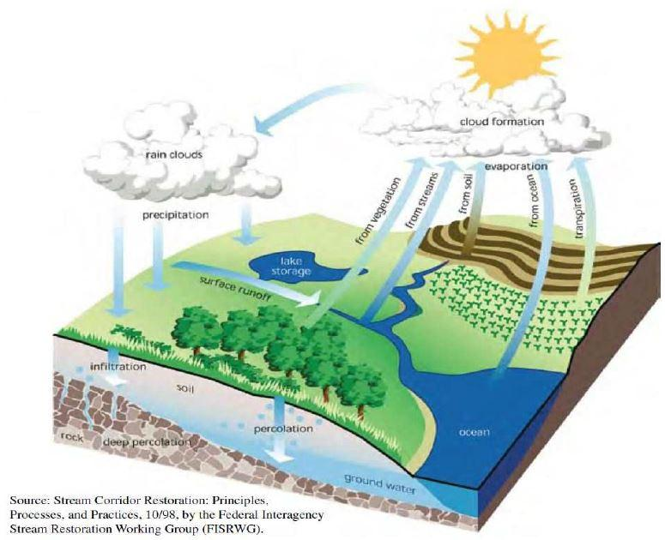

Figure 2: Local Water Cycle for Undeveloped and Developed Acre
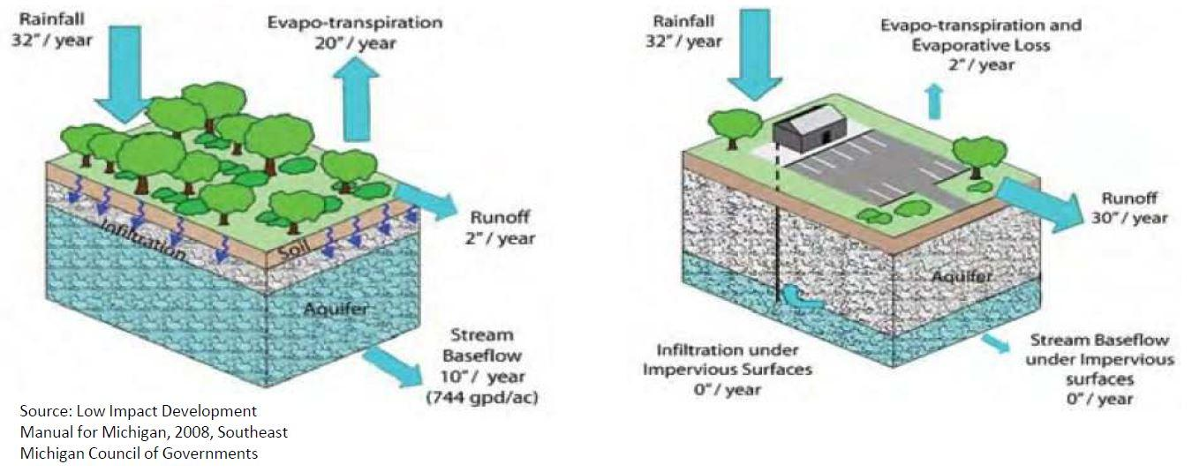

Association Master Topographic Plan
The following figures provide the stormwater collection and distribution system, as it was installed by the original developer.

Stormwater Distribution System Outlets
Attached as Attachment A is a typical diagram showing a preferred stormwater distribution system outlet arrangement. This diagram shows the primary components of the outlet, which along with their benefit to the stormwater system, are outlined below. The components noted below are the preferred method of discharging surface runoff; however, alternate arrangements and materials may also be sued. Please consult Attachment B or the MSHOA Sewers & Drainage Committee for approvals regarding alternate stormwater distribution system outlet materials and/or arrangements.
Discharge Pipe: The discharge pipe is the final piece of the stormwater distribution system, and is typically composed of concrete piping, but may also be a plastic material known as HDPE (high density polyethylene). These pipes are 12-18” in diameter and originate from the catch basins within the community’s roadway curbs or yards.
Level Spreader (Rip Rap): Immediately beyond the discharge pipe is a flat area, typically comprised of stone (rip rap) which is used to slow the flow of water discharging the stormwater system. This slowing of the discharge water serves two purposes: to minimize erosion due to fast-flowing water, and to allow sediment to drop out of the water. The level spreader will generally have a fabric material under the stone to hold the soil base in place.

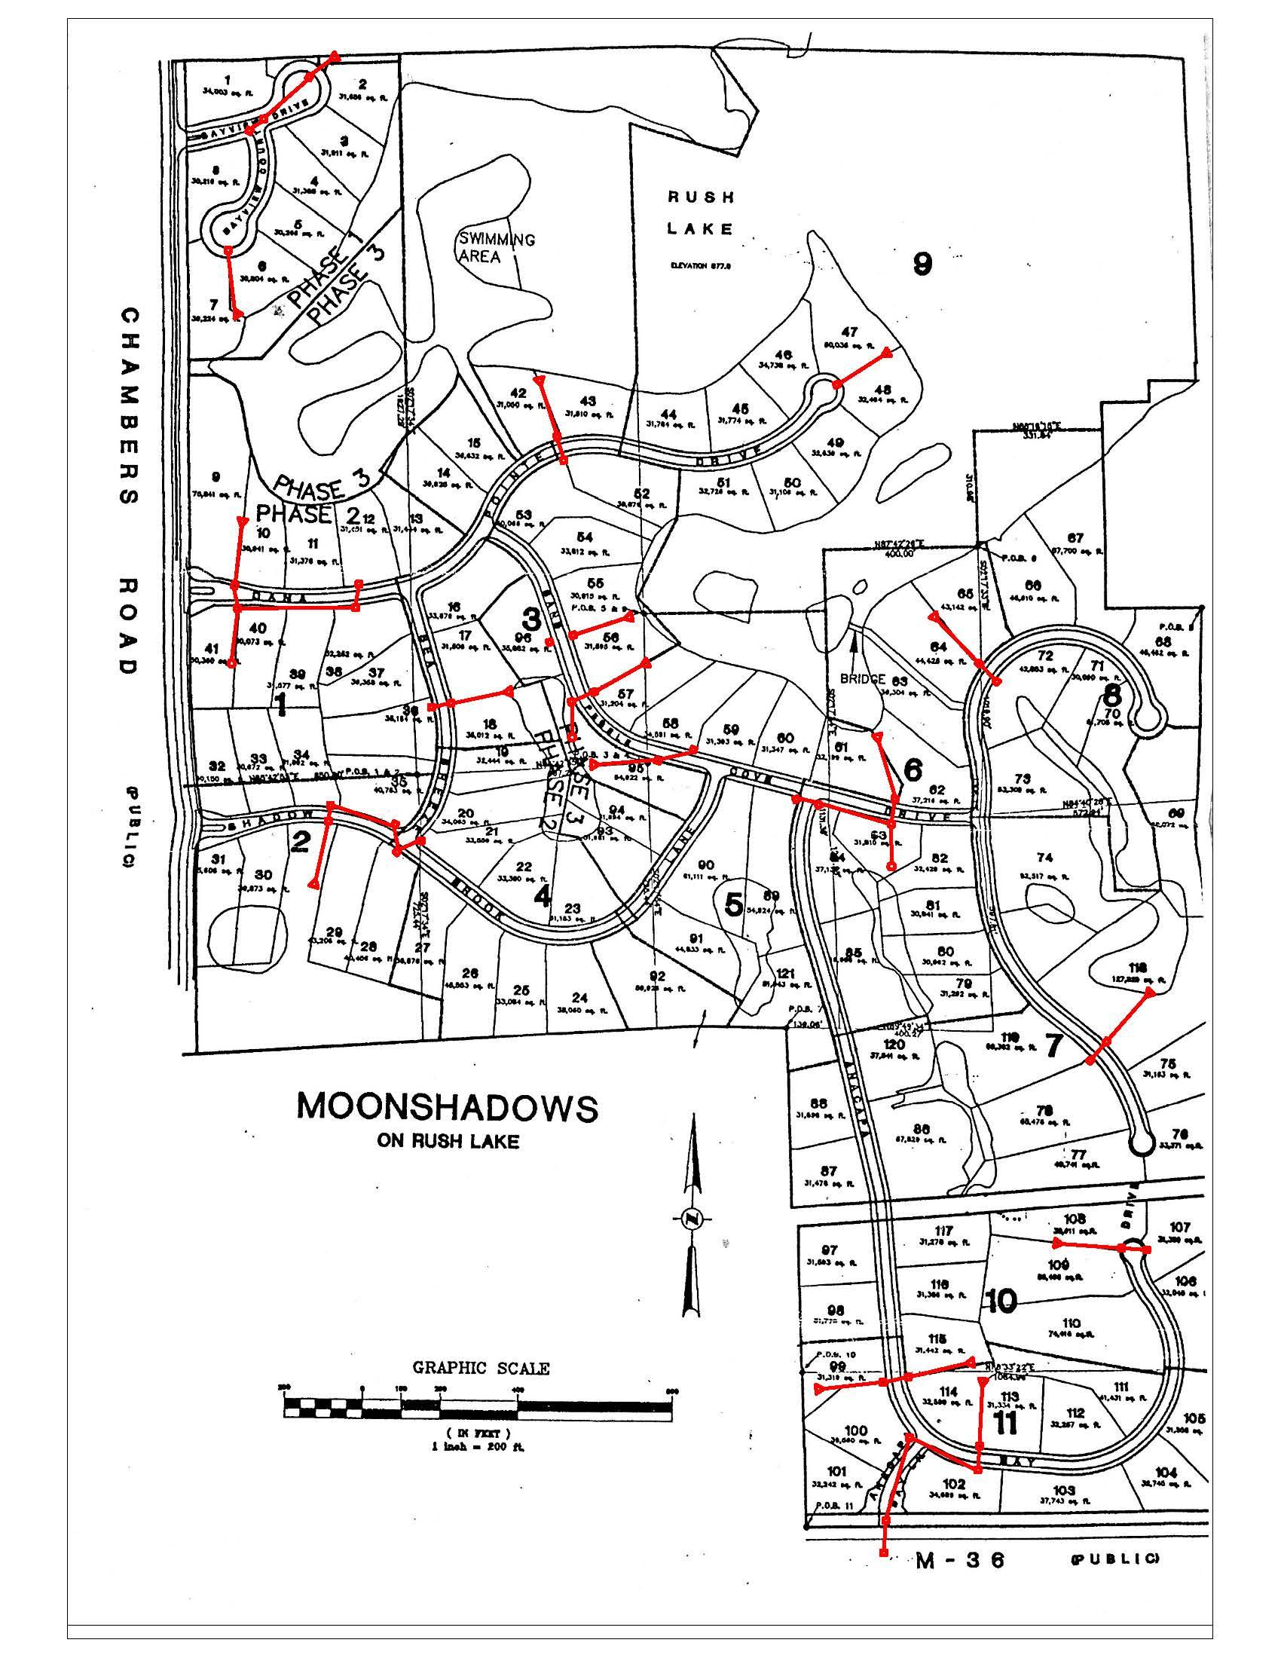
Figure 3: Association Master Topographic Plan

Vegetated Filter Strip/Bioswale: Once the runoff is slowed to a proper speed by the level spreader, the runoff will pass through an area of vegetation. A flat area of vegetation is a filter strip, whereas if a shallow ditch is present, it is considered a bioswale. The vegetative ground cover typically serves to further filter the water, as there is a chemical reaction between the greenery and contaminants in the runoff. The ground cover also serves to further slow the flow of runoff to allow infiltration back into our aquifer, recharging the groundwater supply to our wells and avoiding direct runoff from entering our ponds and Rush Lake. Refer to Attachment B for vegetation which is recommended for use in southeast Michigan as vegetated ground cover for filter strips or bioswales.

Stormwater System Maintenance Plans
Maintenance of the stormwater collection and distribution system, as well as the system’s outlets, begins before runoff enters the systems. As sediment and debris collect oils and other hazardous materials on the MSHOA road surfaces, it is critical that the volume of this material which enters the stormwater system is minimized. This minimization of debris is the responsibility of the Association, as well as each Homeowner. To support this effort, the Association will contract street or curb and gutter cleaning services as the Board of Directors sees fit to remove debris from the community owned street surfaces. This is an additional cost to the Association, and may cause an impact to the Annual Dues for the Association. In order to minimize this debris, Homeowners are expected to clean lawn clippings from the road surface on a regular basis, by direction mower discharges towards the center of their lot and/or blowing clippings following completion of mowing.
Catch basins also require a regular maintenance schedule to ensure minimal sediment is passing through, and that proper flow paths are maintained for surface water runoff. These flow paths may be maintained through regular flushing and/or vacuuming of catch basins and/or piping systems. Typical frequency of catch basin and stormwater piping cleaning is every 5-7 years with typical residential exposure. As a result, the Association will develop a rotational cleaning schedule for the multiple stormwater collection and distribution systems to ensure that each system will be cleaned every 7 years, at a minimum.
Stormwater distribution system outlets require regular inspection by the property owner to ensure proper functionality. The MSHOA Sewers & Drainage Committee will assist in the property owner’s yearly inspections of distribution system outlets, at the property owner’s request. The maintenance of these outlets is also the responsibility of the property owners, with the Common Ground outlets being the Association’s responsibility. With a proper outlet design installed, the maintenance of the outlet structure and adjacent level spreader and infiltration area will require only minor routine maintenance, such as replanting of vegetative ground cover and regeneration (rotating) of aggregate to clean out sediment. Inspection checklists provided in the following section may be used to determine when maintenance is required on stormwater system outlets.

Inspection Checklist
Attached in Attachment 3 are checklists which may be used by Homeowners and the MSHOA Sewers and Drainage Committee for annual and periodic inspections of the stormwater distribution system and its outlets. Following inspections, please submit the completed forms to the MSHOA Sewers and Drainage Committee (info@moonshadowshoa.org) for filing.

Attachment 1
Typical Stormwater Distribution System Outlet Arrangement
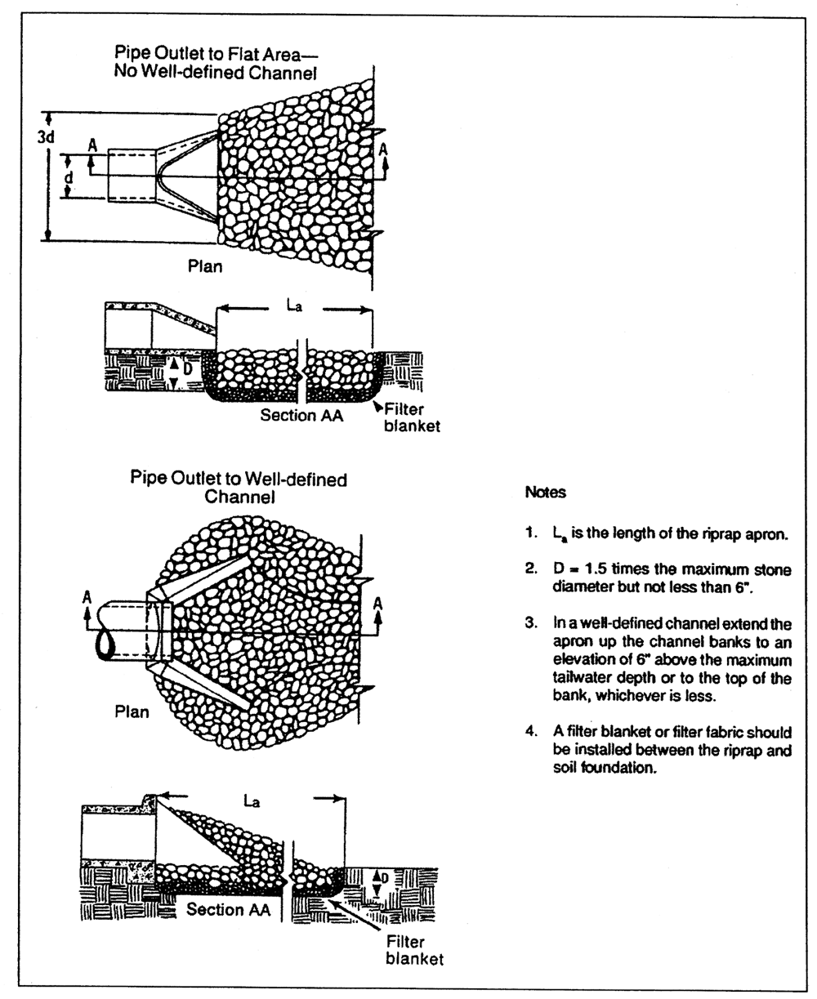

Attachment 2
Recommended Vegetative Ground Cover. [Source: Low Impact Development Manual for
Michigan, Appendix C, 2008, Southeast Michigan Council of Governments (SEMCOG)]

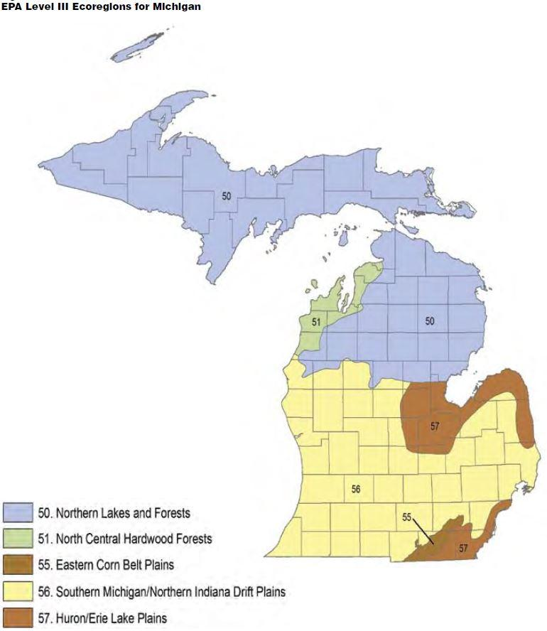
Attachment 3
Inspection Checklist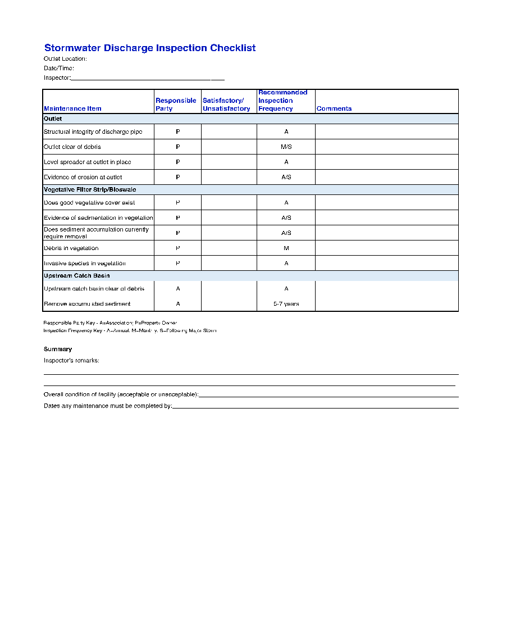

Appendix B
Plant Zone Recommendations
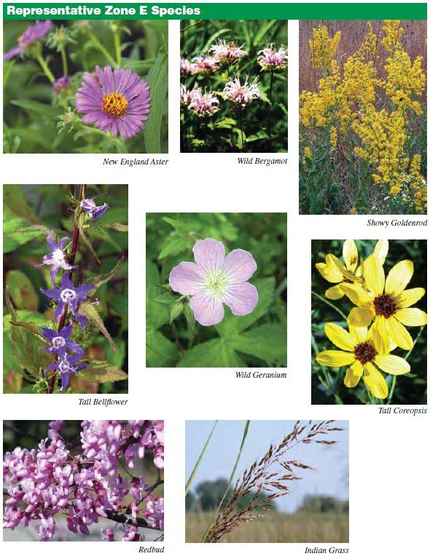
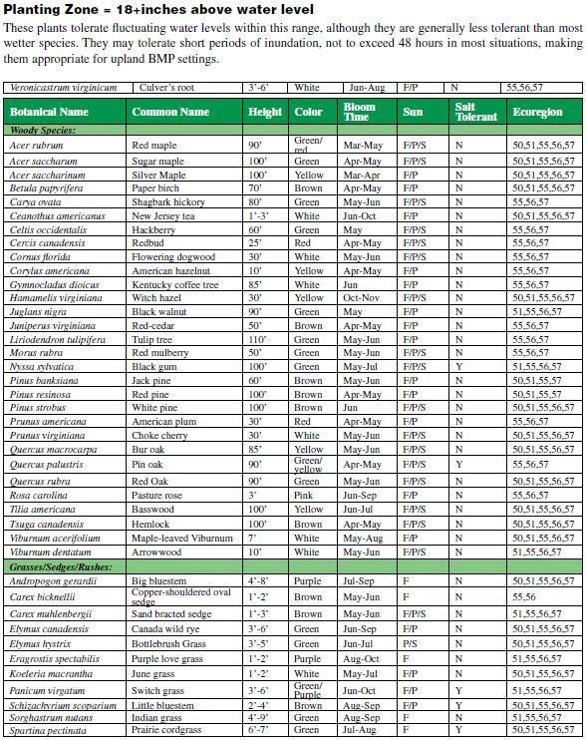

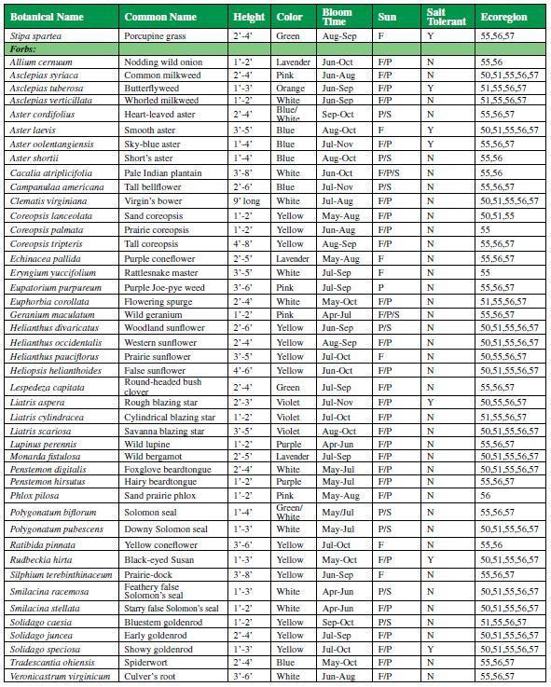

APPENDIX C

Example Trash Container Screen
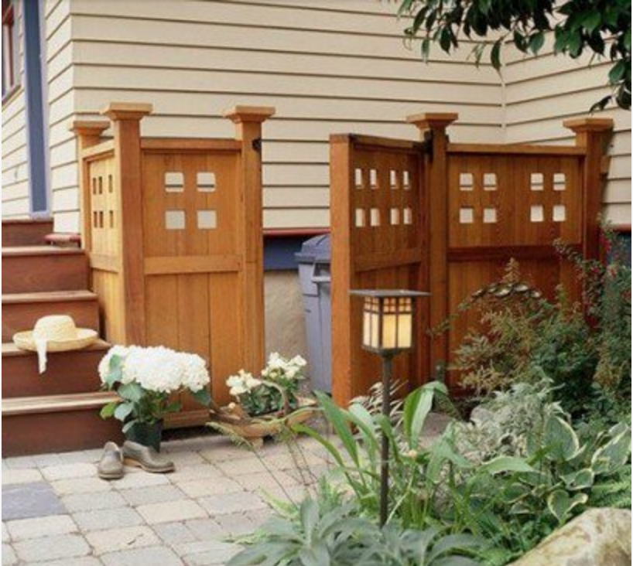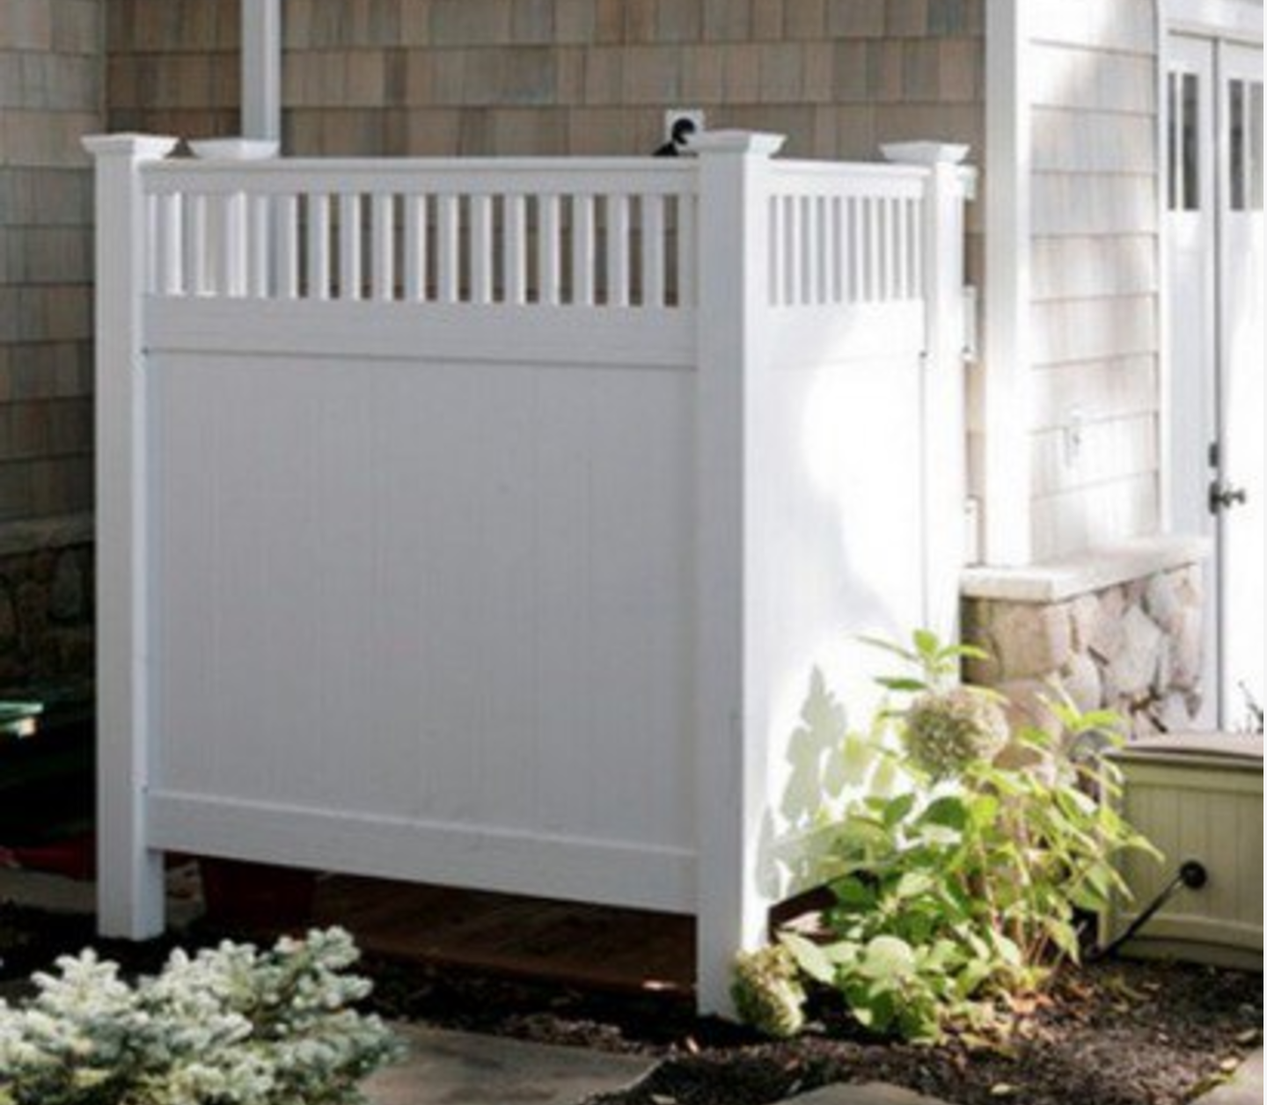

Multi-purpose: think about hiding the air conditioner in combination with a place to hide the trash cans.

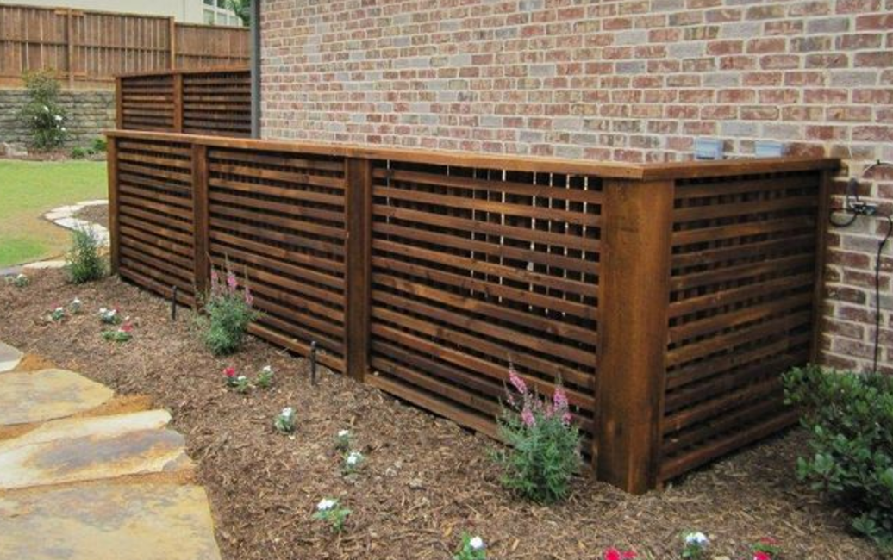
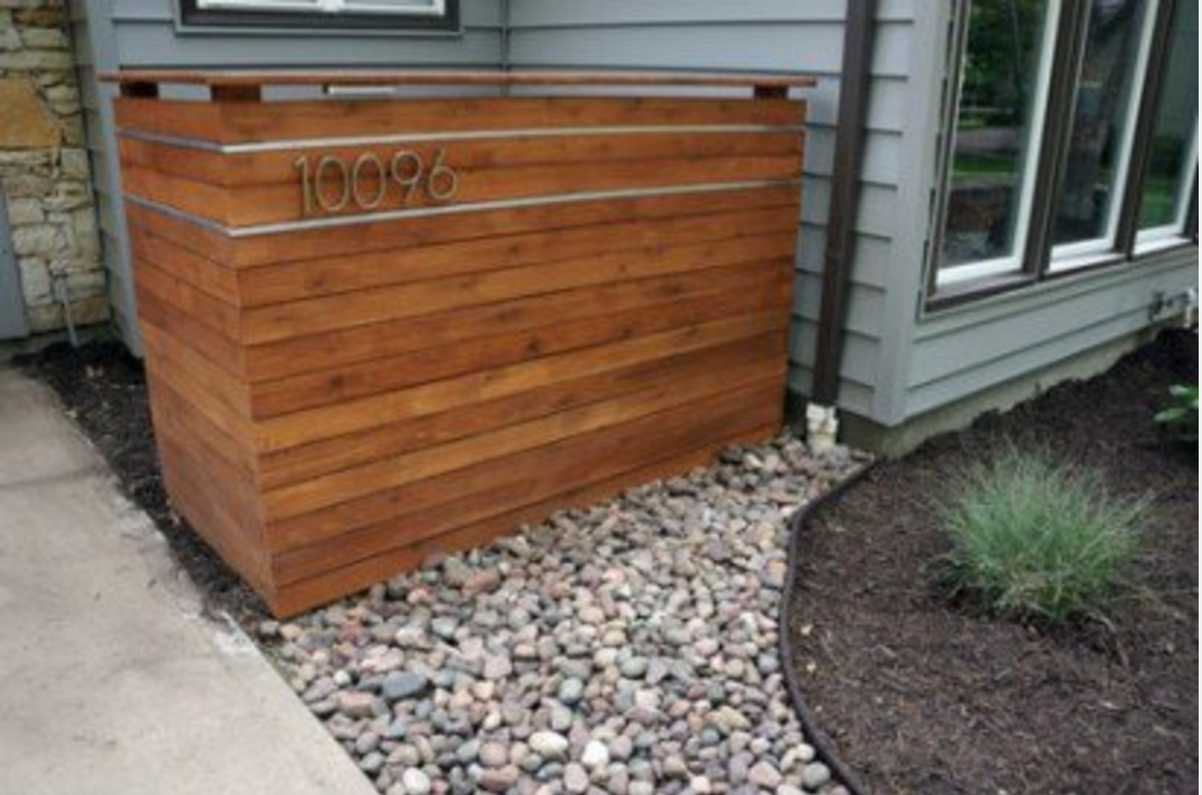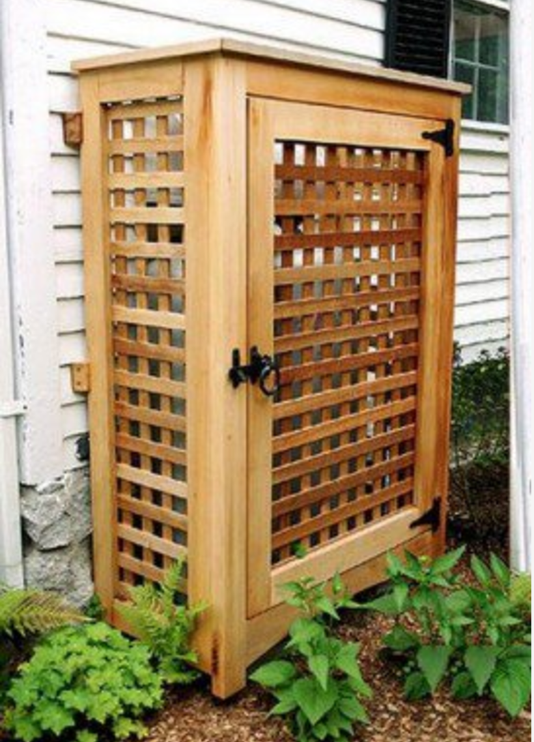

Try and integrate plantings into the trash can screen, even using all plantings could work (and likely be easier maintenance).

